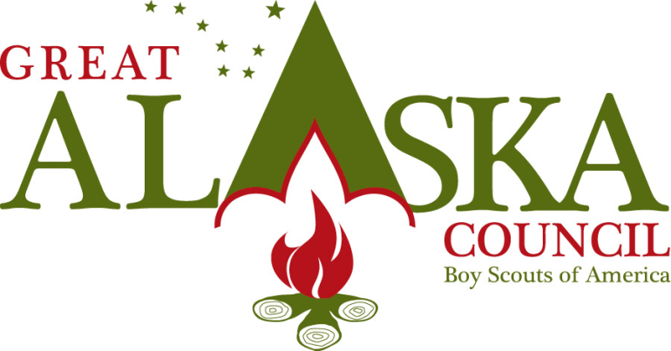
3117 Patterson St. Anchorage, Alaska 99504 (800) 478-9549 Fax (907) 338-6273 www.akultimatehighadventure.com

Ultimate High Adventure
Kachemak Bay Backpacking
Youth participating in this trek must be 13 by May 1 of the year they are participating.

Kachemak Bay is the home to Alaska’s first state park. The park encompasses approximately 400,000 acres of mountains, forests, glaciers and ocean. Katchemak Bay is critical habitat area and haven for many species of marine life including sea otters, porpoise, seals, and whales. The park is also home to black bears, mountain goats, coyotes, wolves, and various species of birds. Access to the park for us will by water taxi from Homer Spit to Haystack Rock.

The trek up the Wosnesenski drainage, known locally as the “Woz”, is one of the best hikes in Kachemak Bay State Park. You can see abundant wildlife and evidence of more, including moose, bear, and wolf. The Woz drainage is remote and you are likely to have it to yourself, as few hikers venture up here. If time permits and you are up to it you can hike 5 miles further up river to the terminus of the Wosnesenski Glacier. There are grand views on this additional 5 miles of Doroshin River drainage and the Doroshin Glacier.

Depending on how many days you want to backpack and how fast you are able to travel you can cover any amount of trails, hike into Grewingk glacier, hike to fabulous view points and eventually make it to Humpy Creek where your water taxi will pick you up for your trip back to Homer Spit. To get to the Humpy Creek Trail You will be crossing Grewingk Creek on a hand operated tram. You will want gloves for this endeavor. This is a wonderful trek and beautiful scenery abounds.

The cost of this trek with a maximum of 12 people for 7 days is $13,500.00
The cost of this trek with a maximum of 12 people for 10 days is $15,300.00

