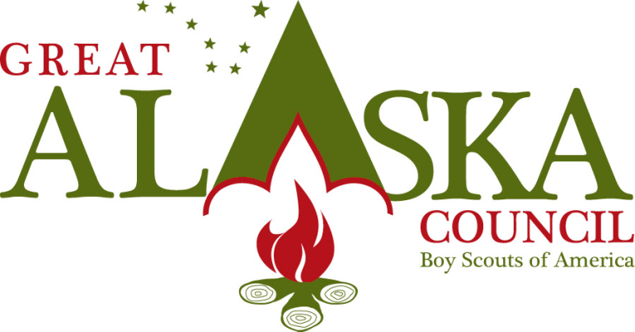
3117 Patterson St. Anchorage, Alaska 99504 (800) 478-9549 Fax 1-888-343-0329 www.akultimatehighadventure.com

Ultimate High Adventure
Resurrection Bay Caines Head Sea Kayaking
Youth participating in this trek must be 13 by May 1 of the year they are participating.

Resurrection Bay lies atop the northern Gulf of Alaska, sandwiched between the massive mile-high Harding and Sargent ice fields. This is Alaska’s largest, year-round ice-free seaport with road, rail and air routes linking south central to interior Alaska. This is also the gateway to the Kenai Fjords: a series of long, glaciated indentations that form one of the wildest stretches in the Gulf of Alaska.

The islands at the bay’s mouth tame the ocean swell and partially protect the upper bay from the wrath of the gulf coast storms. They also provide outstanding scenery.

You will be Kayaking from Lowell Point in Seward to the South Beach in Caines Head State Recreation Area. Caines Head is the site of the old Seward Harbor Defense network constructed by the Army during the early stages of World War II. Fort McGilvary, built atop Caines Head, was a six inch gun battery designed to sink enemy ships entering Resurrection Bay. Today, the fort with its deserted hallways and rusted gun platforms is part of the 5,961 acre Caines Head State Recreation Area. The fort is open to the public, but bring a flashlight if you plan to explore the concrete structures. This is an incredible area with wonderful scenery and trails to hike.

The cost of this trek with a maximum of 12 people for 7 days is: $16,200.00

