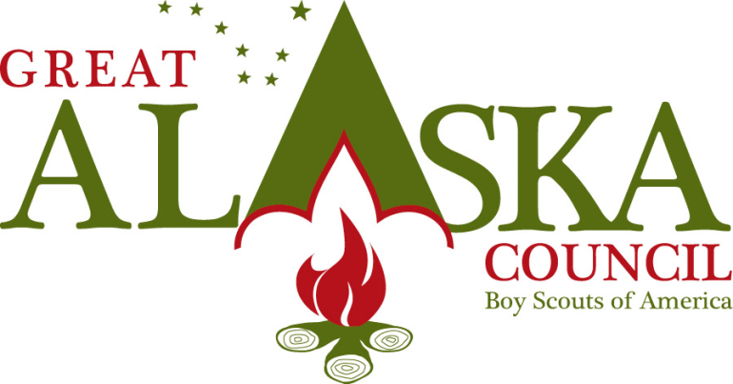
3117 Patterson St. Anchorage, Alaska 99504 (800) 478-9549 Fax (907) 338-6273 www.akultimatehighadventure.com

Ultimate High Adventure
Liberty Falls High Country Backpacking
Youth participating in this trek must be 13 by May 1 of the year they are participating.

A beautiful area that is rarely visited and just across the road from Wrangell St. Elias National Park. You will start your hike out on a fairly nice road, but it gets more rugged, rutted, rocky, and brushy as you ascend. After about 5 miles you will open into the lake. At this point you are in wide open country and the possibilities are many. The ridges all around you will beckon for your exploring. You need to allow yourself several days to explore the region.

This is a 24 mile loop with the possibilities to be much more with endless ridges and valleys to explore. This is a wonderful seven day or more trek.

The cost of this trek with a maximum of 12 people for 7 days is: $12,600.00

